Admin Documentation

1. **Login Page**:

**URL:** [**https://120army.com/admin/**](https://120army.com/admin/)

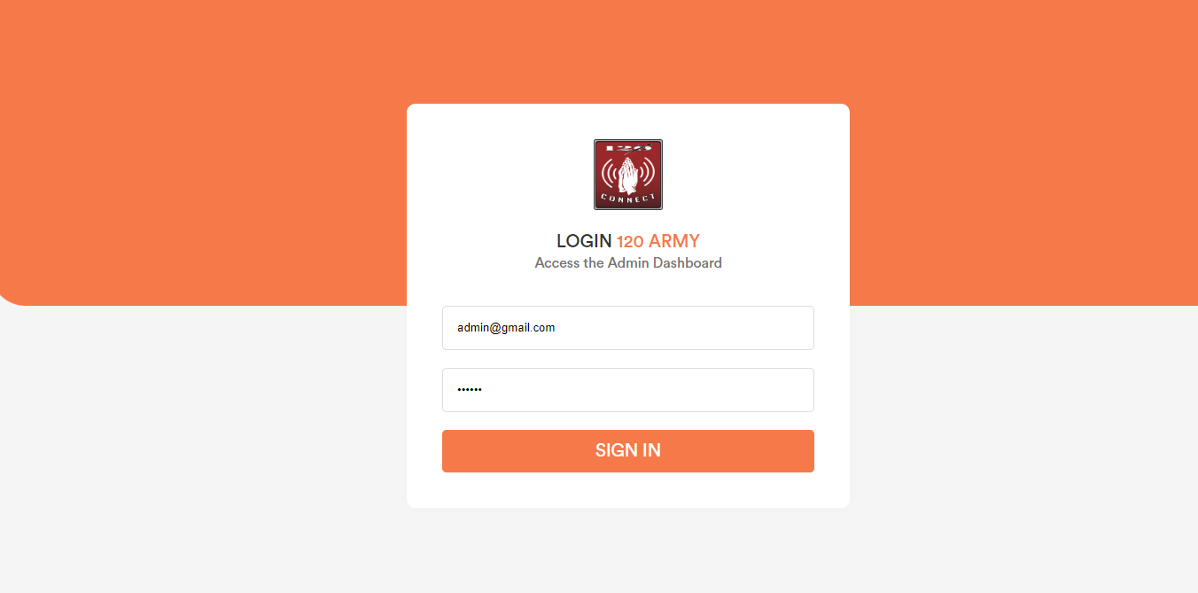

1. **Dashboard:**

After login into the admin panel user will be redirect to the dashboard page.

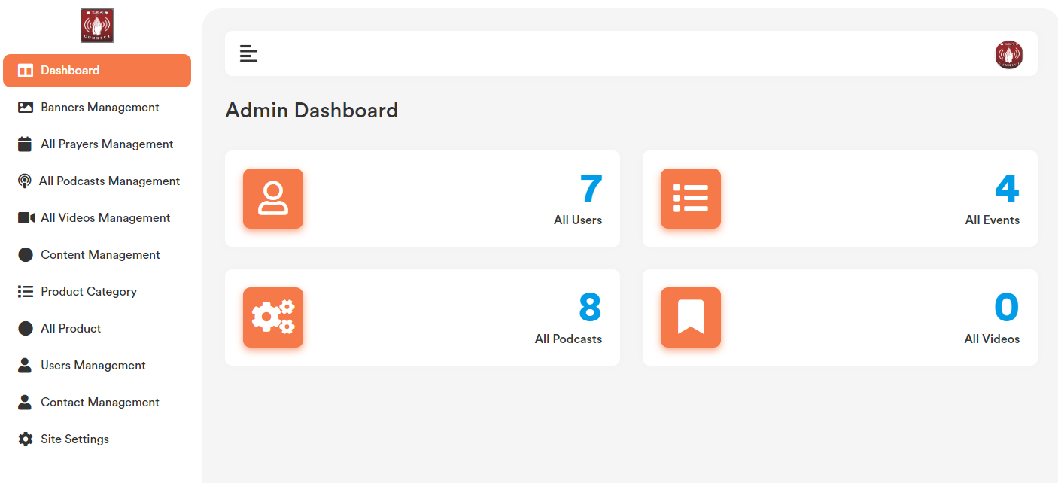

1. **Banner:**

Banner added by admin will show in the website frontend.

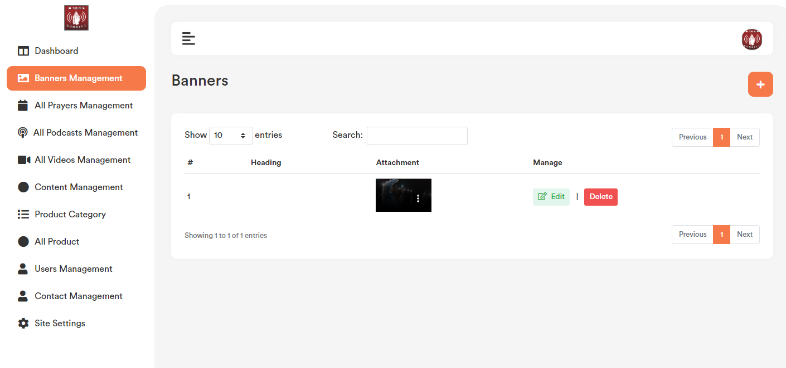

1. **Add Banner:**

Banner list page top right corner click on the “+” icon. User will get a form to add new banner. Please check the below screenshot.

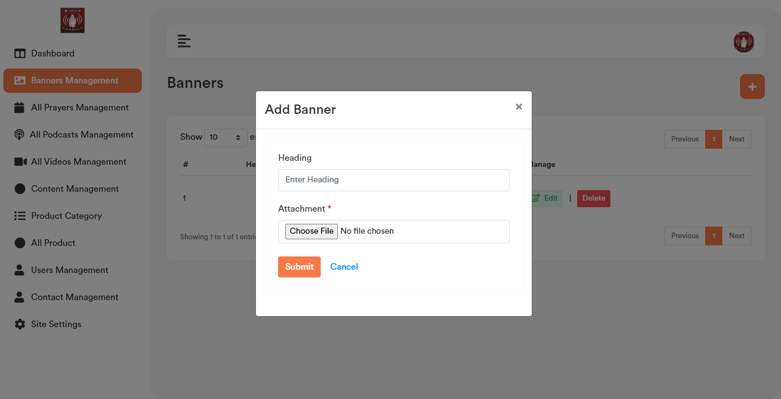

**b. Edit Banner:**

Banner list page for each record if user click on the “Edit” option, it will open a form containing the existing banner data for that particular record. After making the change click on the “Save Changes” button. It will update the existing record with the updated data. Please check the below screenshot.

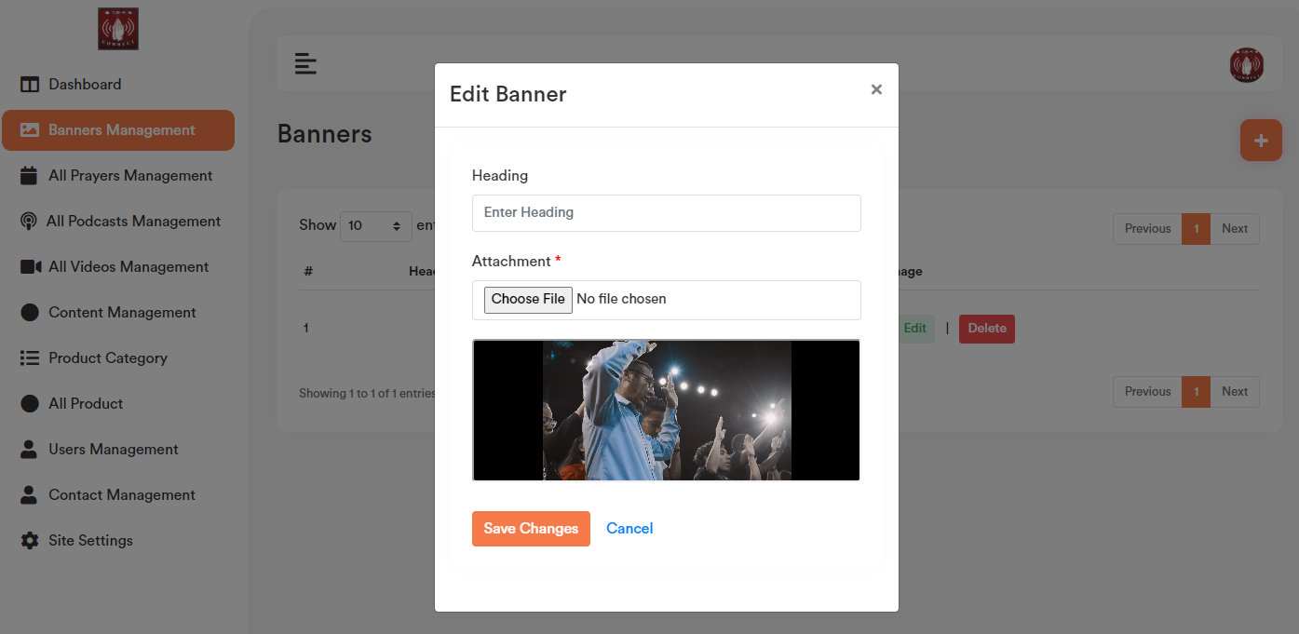

1. **Delete Banner:**

If user click on the “Delete” Button, user will get a confirmation popup. Once confirm it will delete the related banner data.

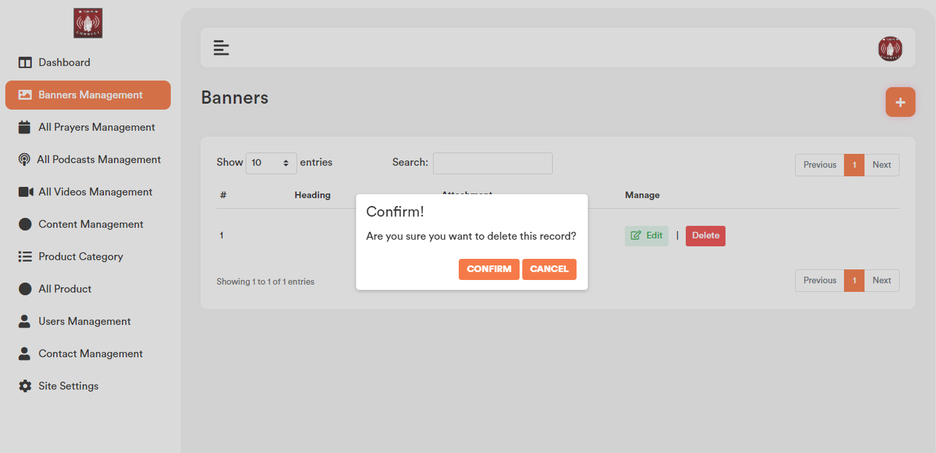

1. **All Prayer Management:** All the prayer added by apps and from admin portal will show in the prayer management list.

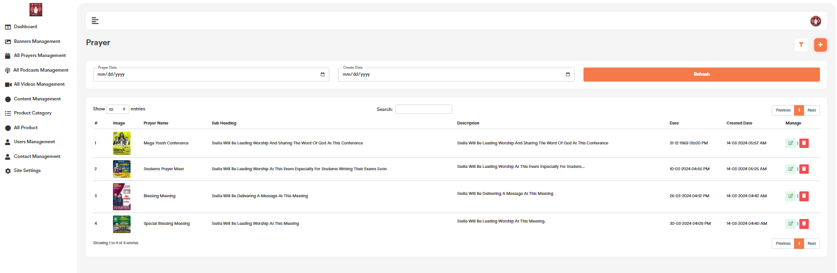

1. **Add Prayer:**

Prayer list page top right corner click on the “+” icon. User will get a form to add new Prayer. Please check the below screenshot.

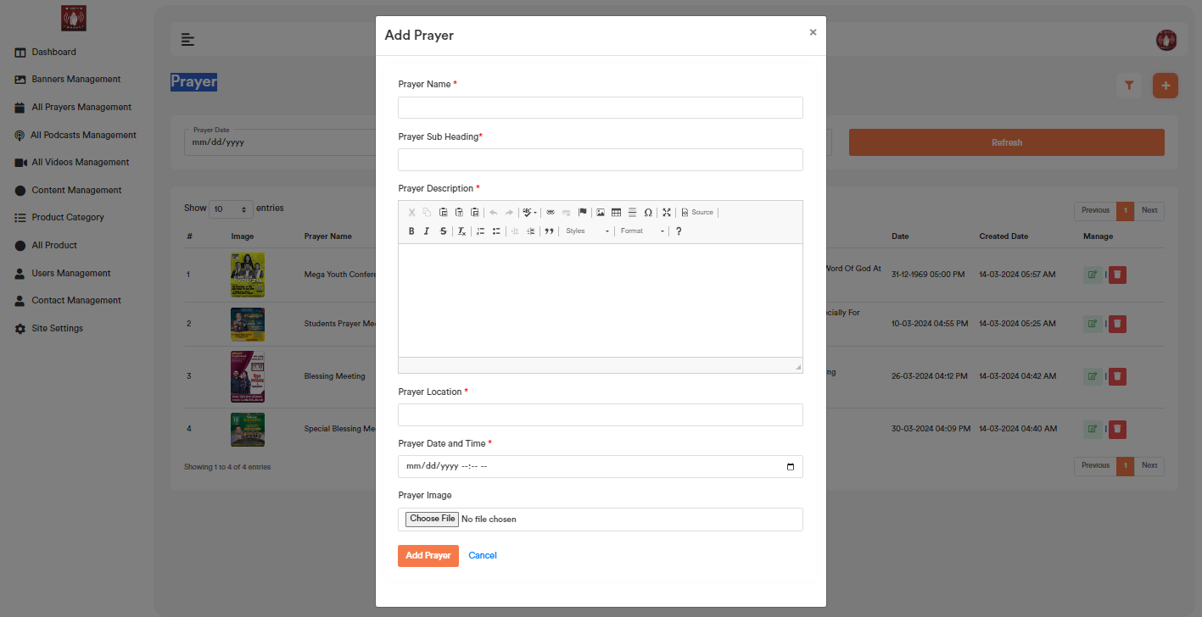

1. **Edit Prayer:**

Prayer list page for each record if user click on the “Edit” option, it will open a form containing the existing data for that particular record. After making the change click on the “Save Changes” button. It will update the existing record will the updated data. Please check the below screenshot.

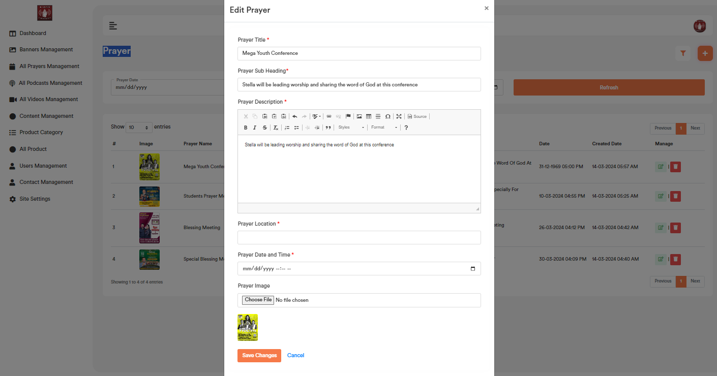

1. **Delete Prayer:**

If user click on the “Delete” Button, user will get a confirmation popup. Once confirm it will delete the related prayer data.

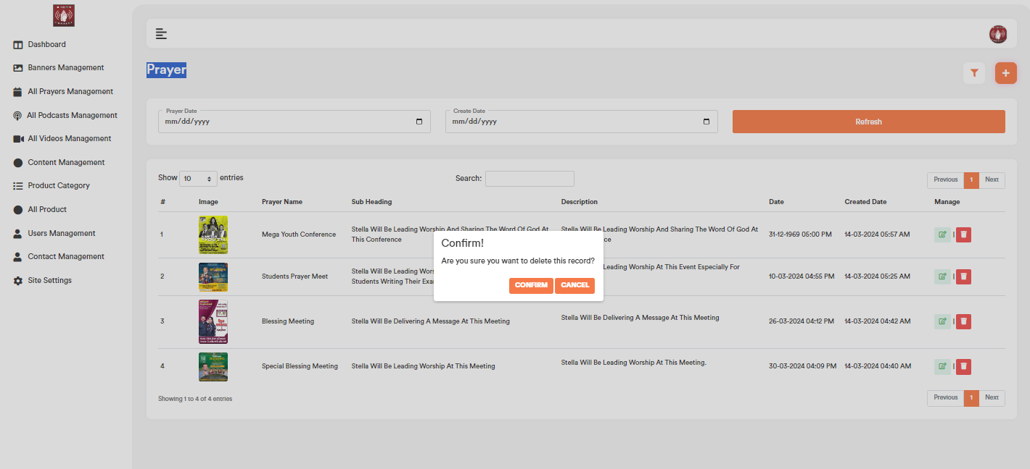

1. **Prayer Filter:**

Based on the added prayer date and created date admin will be able to filter any prayer from the Prayer list.



1. **Prayer Search:**

Admin can search any record by typing text on the search textbox.



1. **All Podcast Management:**

Admin will be able to add podcast.

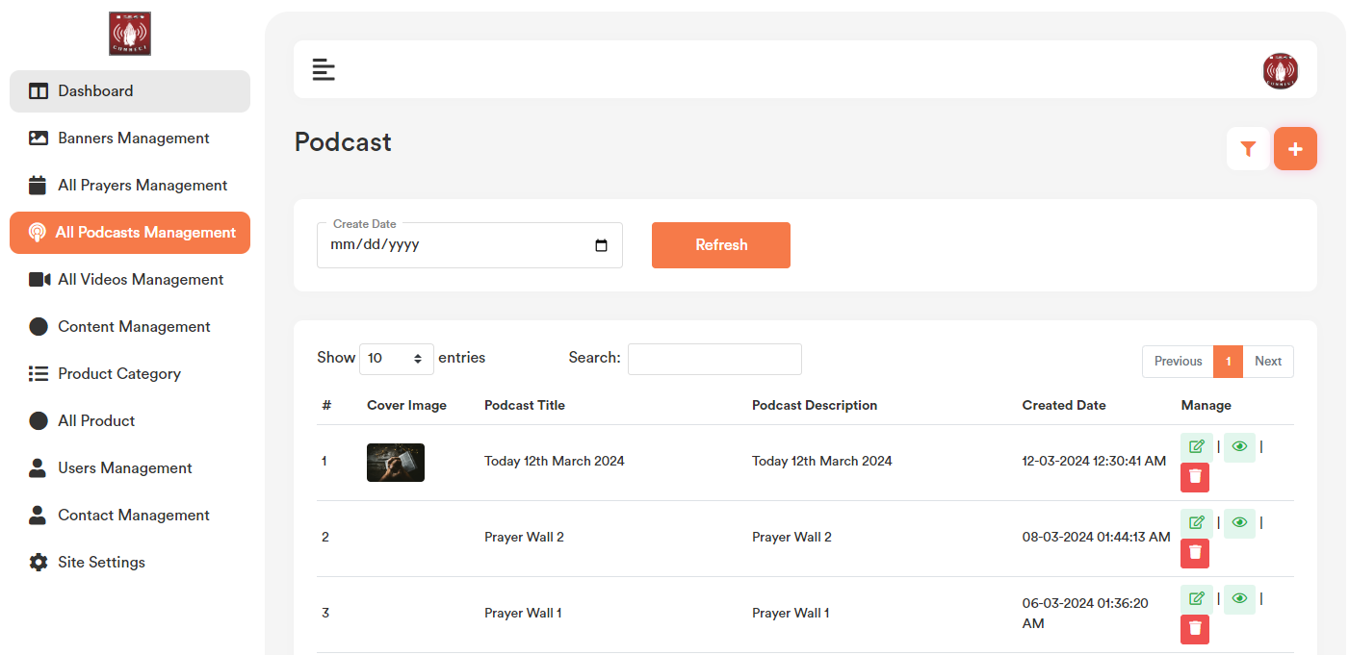

1. **Add Podcast Management:**

Podcast list page top right corner click on the “+” icon. User will get a form to add new podcast. Please check the below screenshot.

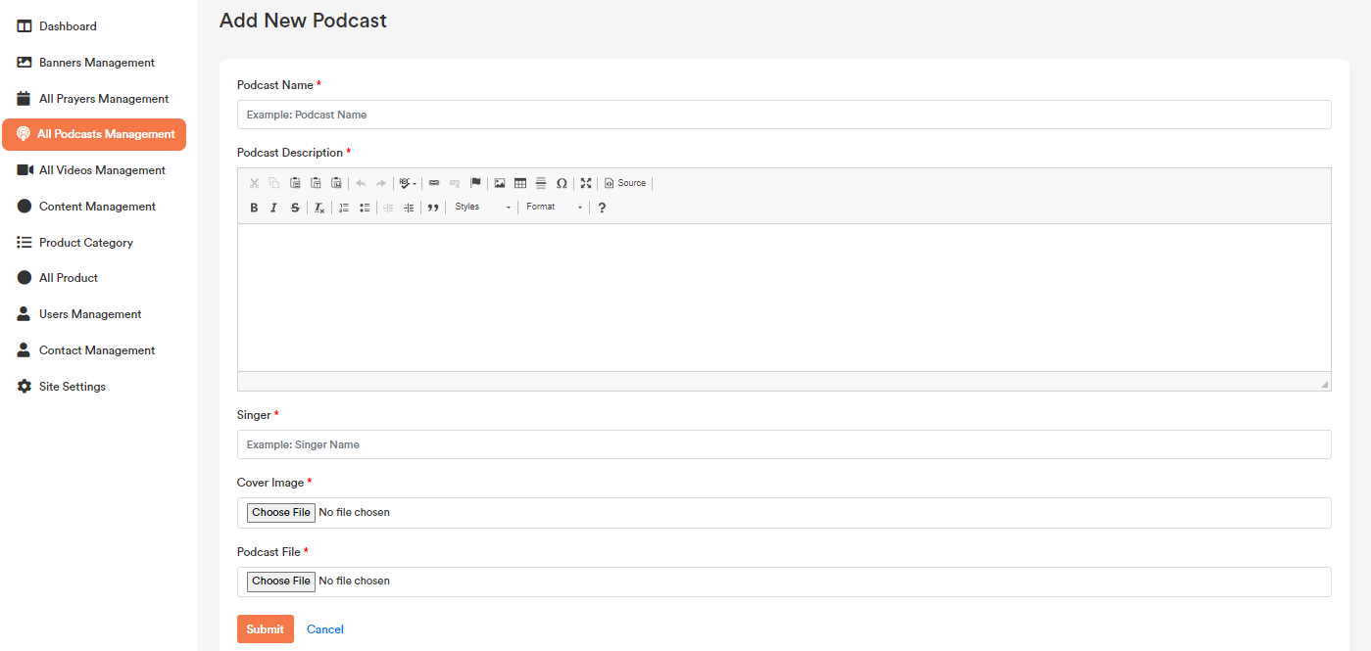

1. **Edit podcast:**

Podcast list page for each record if user click on the “Edit” option, it will open a form containing the existing podcast name data for that particular record. After making the change click on the “Save Changes” button. It will update the existing record will the updated data. Please check the below screenshot.

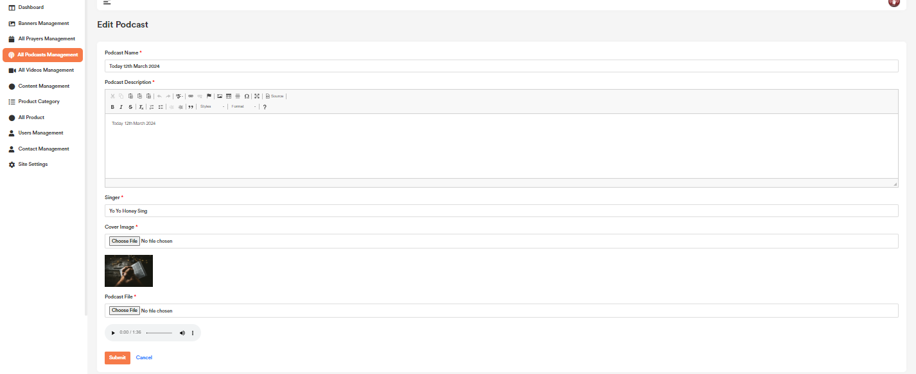

1. **Delete Podcast:**

If user click on the “Delete” Button, user will get a confirmation popup. Once confirm it will delete the related podcast data.

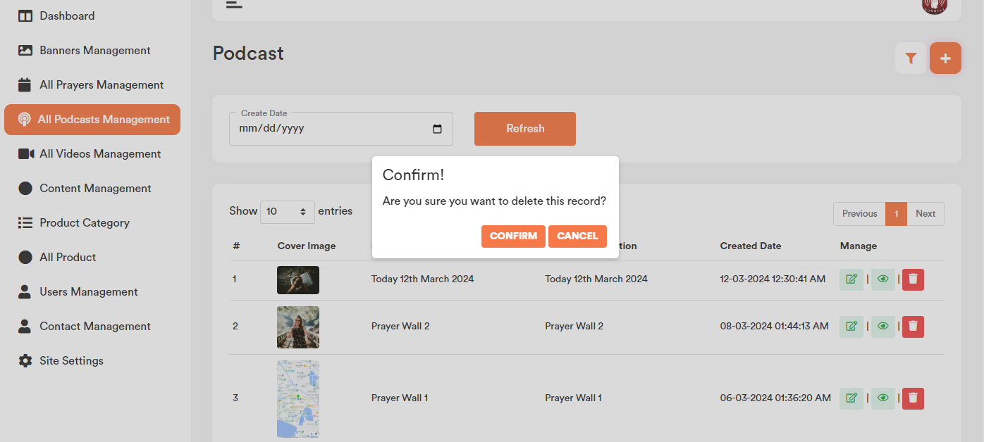

1. **Podcast Filter:**

Based on the podcast created date admin will be able to filter any record from the podcast list.

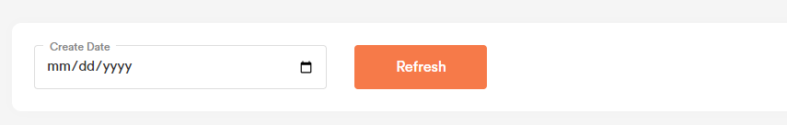

1. **Podcast Search:** Admin can search any record by typing text on the search textbox.



1. **All Videos Management:**

All the listed videos will show in the respective pages.

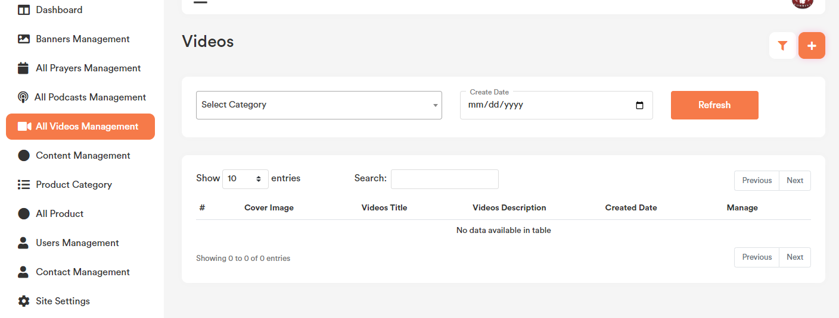

1. **Add Videos:**

Video list page top right corner click on the “+” icon. User will get a form to add new video. Please check the below screenshot.

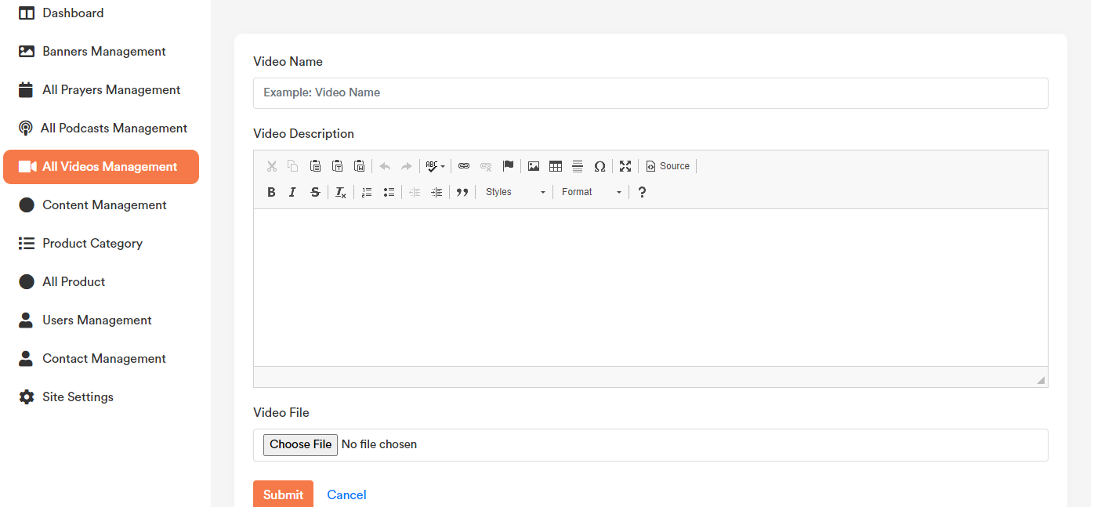

1. **Edit video:**

Video page for each record if user click on the “Edit” option, it will open a form containing the existing video data for that particular record. After making the change click on the “Save Changes” button. It will update the existing record will the updated data. Please check the below screenshot.

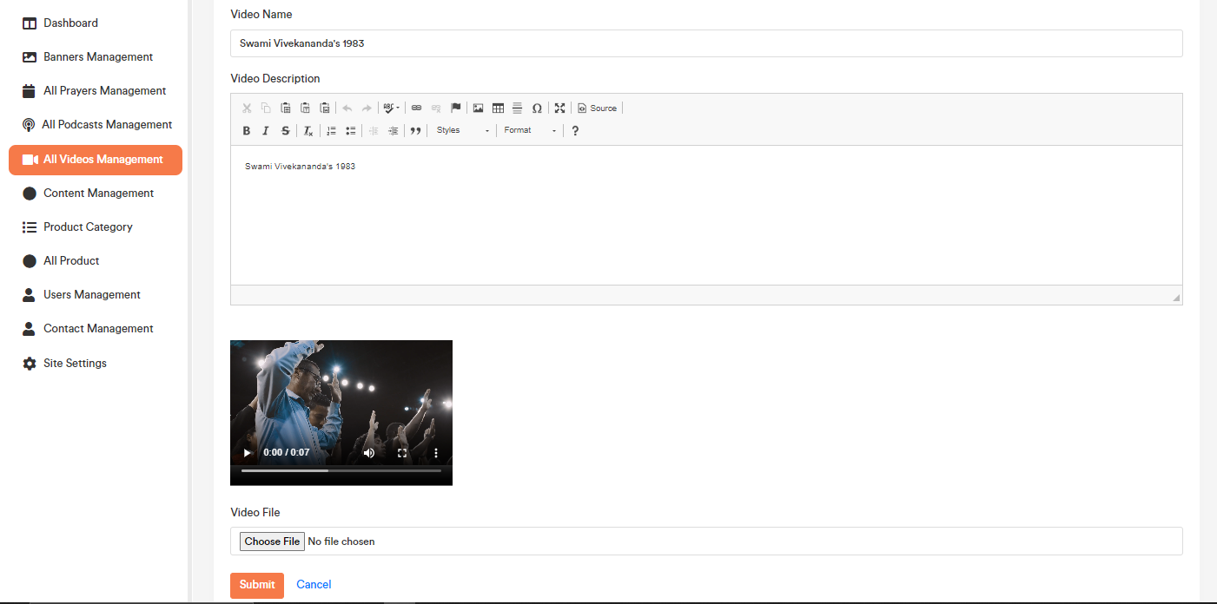

1. **Delete Video:**

If user click on the “Delete” Button, user will get a confirmation popup. Once confirm it will delete the related data.

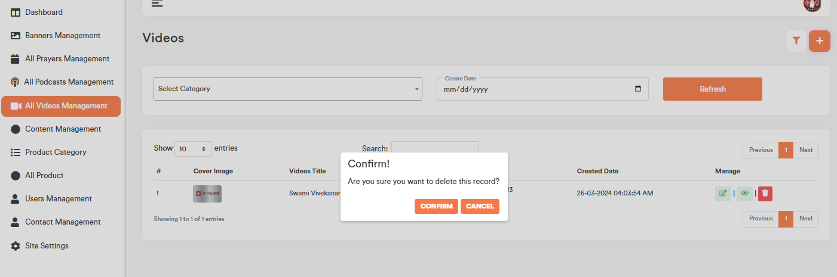

1. **Video Search:**

Admin can search any record by typing text on the search textbox.



1. **Content Management:**

Admin will be able to update or change ‘About Us’, ‘Privacy Policy’, ‘Terms and Conditions’ page content.

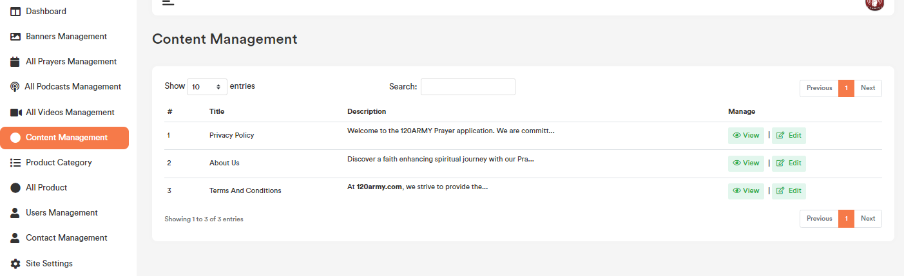

1. **Edit Content Management:**

Content Management list page for each record if user click on the “Edit” option, it will open a form containing the existing data for that particular record. After making the change click on the “Save Changes” button. It will update the existing record will the updated data. Please check the below screenshot.

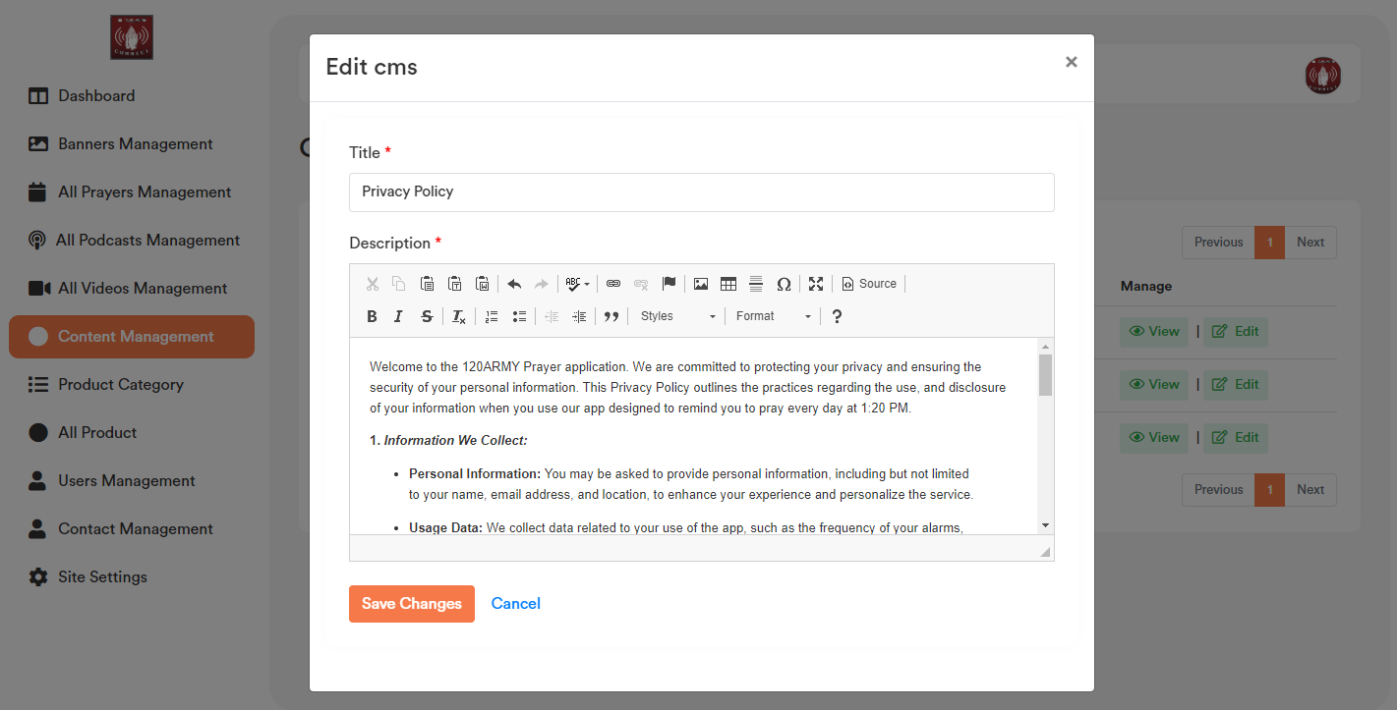

1. **View Content Management:**

Content Management list page for each record if user click on the “View” button option, it will open a modal containing the data for that particular record. Please check the below screenshot.

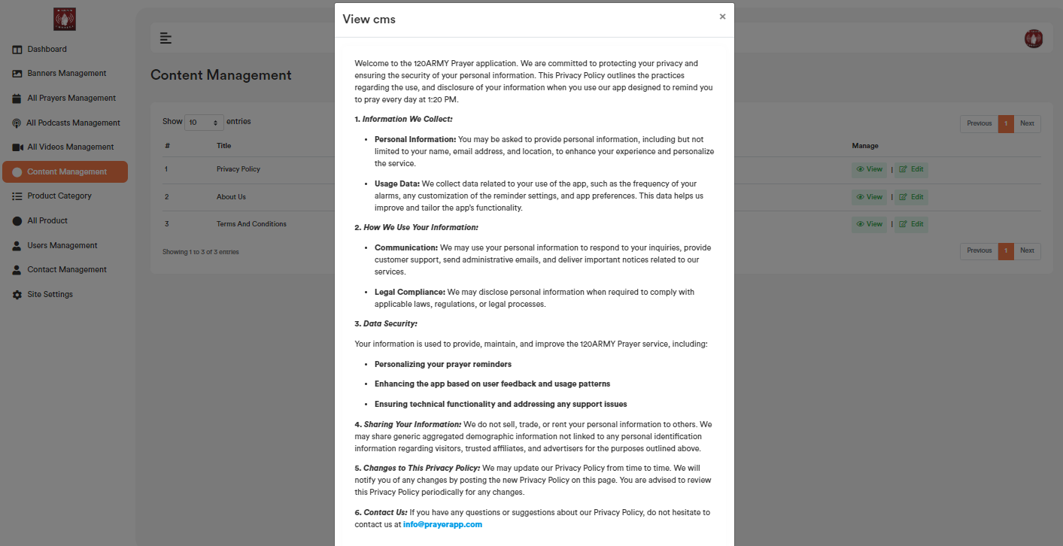

1. **Content Management Search:**

User can search any record by typing text on the search textbox.



1. **Product Category:**

Category added by admin will show in the list.

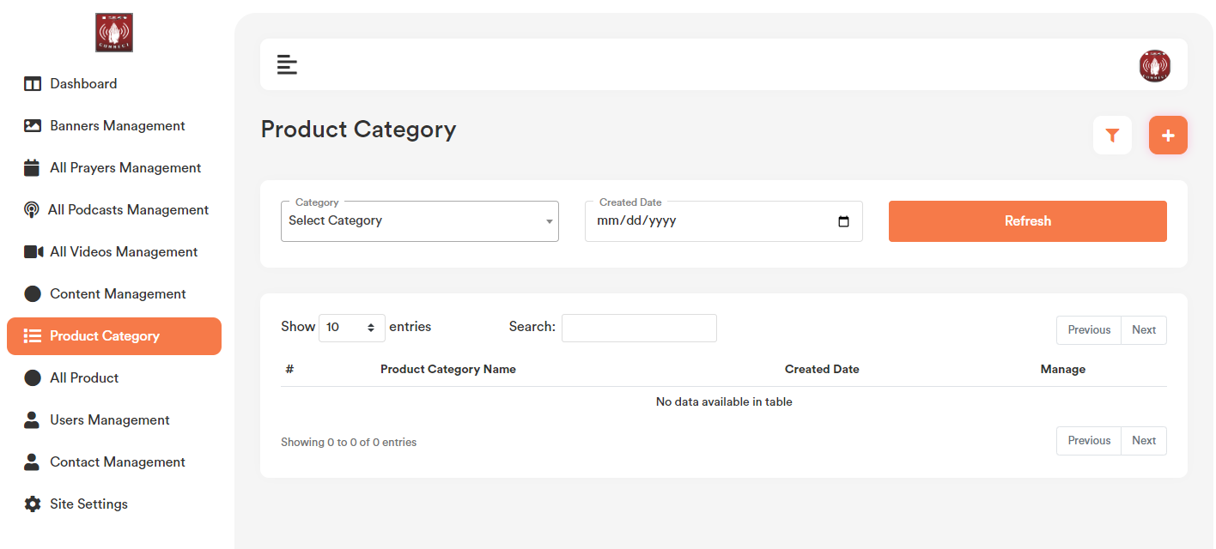

1. **Add Product Category:**

Product Category list page top right corner click on the “+” icon. User will get a form to add new category. Please check the below screenshot.

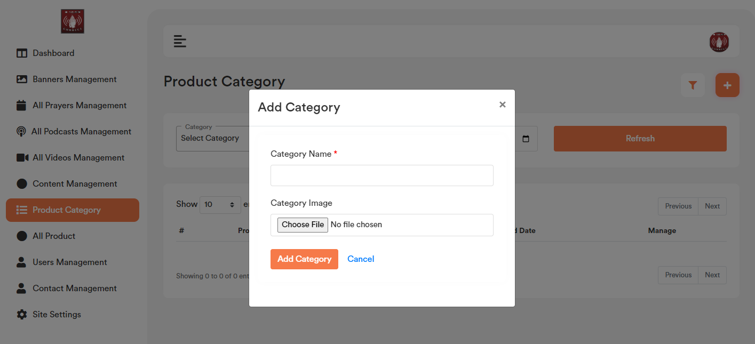

1. **Edit Product Category:**

Category list page for each record if user click on the “Edit” option, it will open a form containing the existing category data for that particular record. After making the change click on the “Save Changes” button. It will update the existing record with the updated data. Please check the below screenshot.

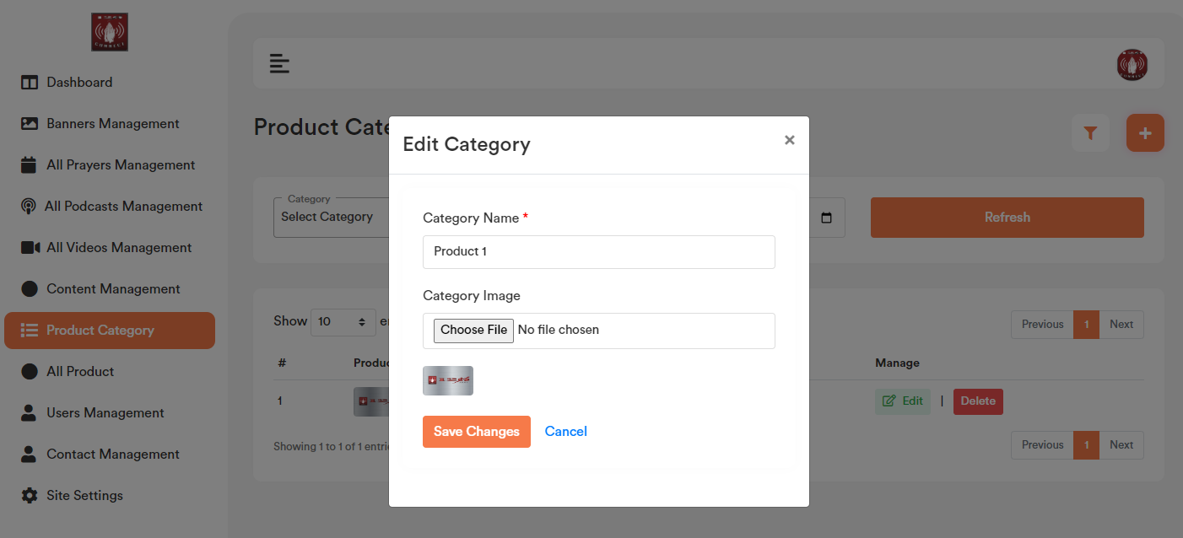

1. **Delete Product Category:**

If user click on the “Delete” Button, user will get a confirmation popup. Once confirm it will delete the related category data. Please check the below screenshot.

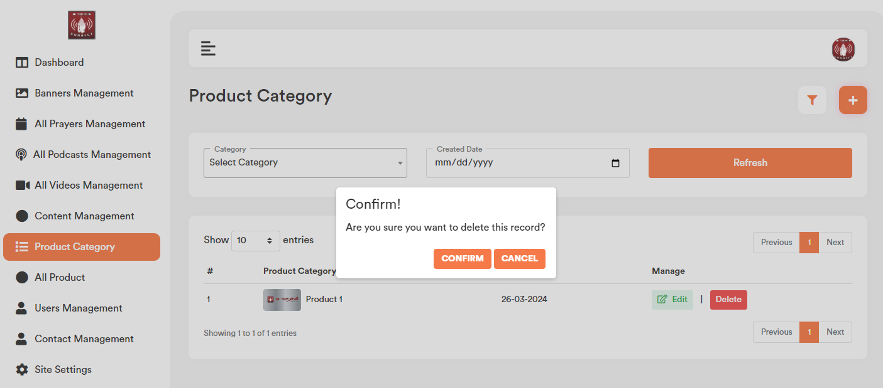

1. **Category Search:** User can search any record by typing text on the search textbox.



1. **Category Filter:** Based on the added category and created date admin will be able to filter any category from the category list.

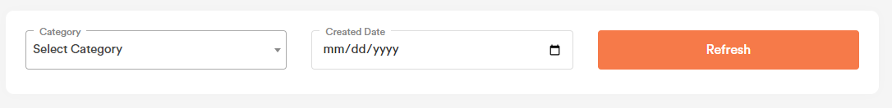

1. **Product:**

Product data will show in the website.

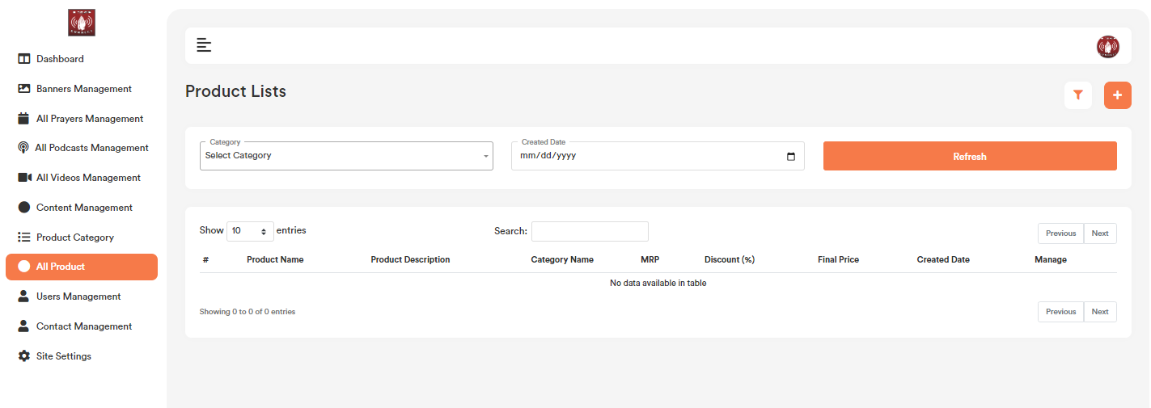

1. **Add Product:**

Product list page top right corner click on the “+” icon. User will get a form to add new Product. Please select the category name from the dropdown first. Please check the below screenshot.

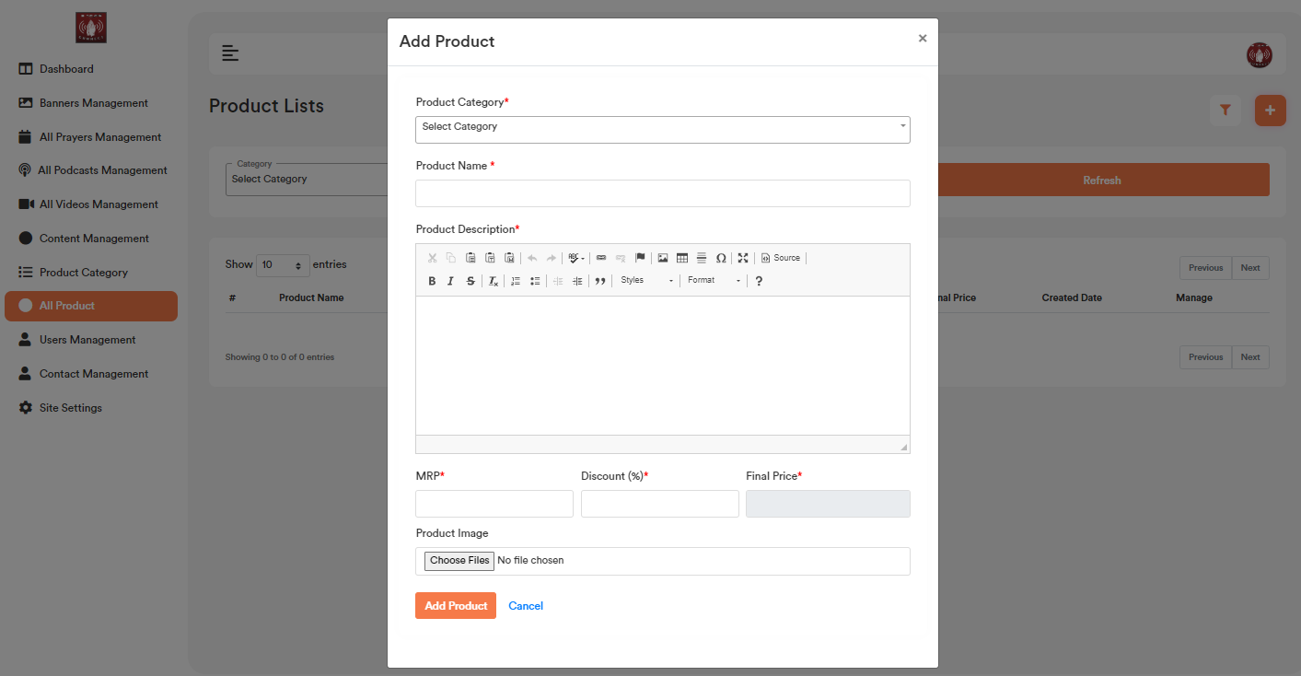

1. **Edit product:**

Product list page for each record if user click on the “Edit” option, it will open a form containing the existing product data for that particular record. After making the change click on the “Save Changes” button. It will update the existing record will the updated data. Please check the below screenshot.

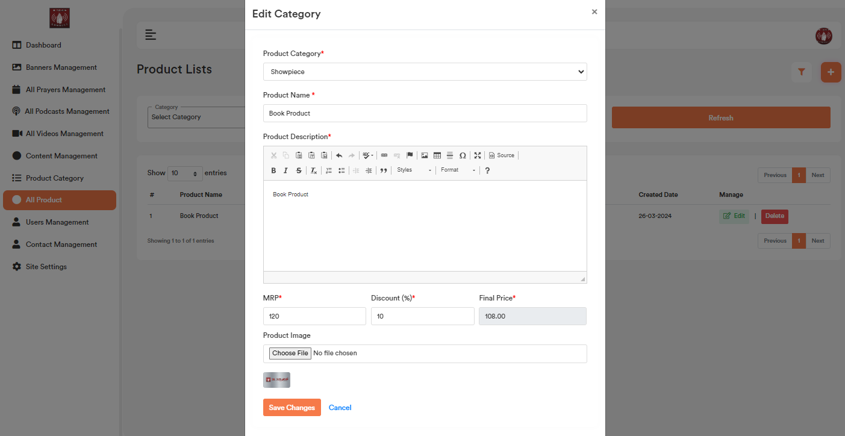

1. **Delete Product:**

If user click on the “Delete” Button, user will get a confirmation popup. Once confirm it will delete the related product data.

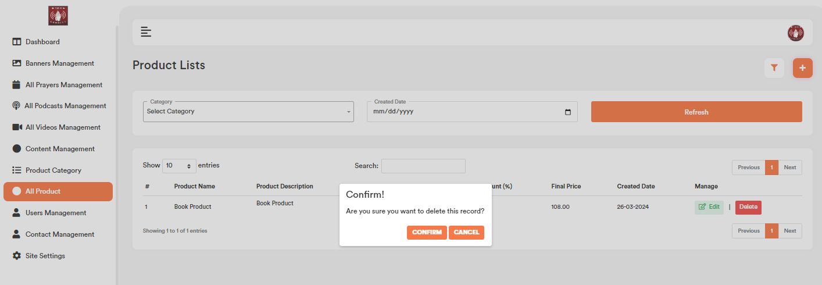

1. **Product Filter:** Based on the product category and created date admin will be able to filter any product from the product list.

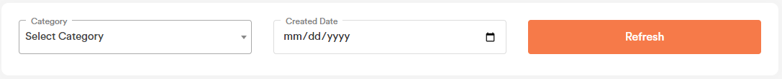

1. **Product Search:**

User can search any record by typing text on the search textbox.



1. **Users:**

All the registered users will be listed in the uses section. Admin can verify user, delete, view password and reset password for the users.

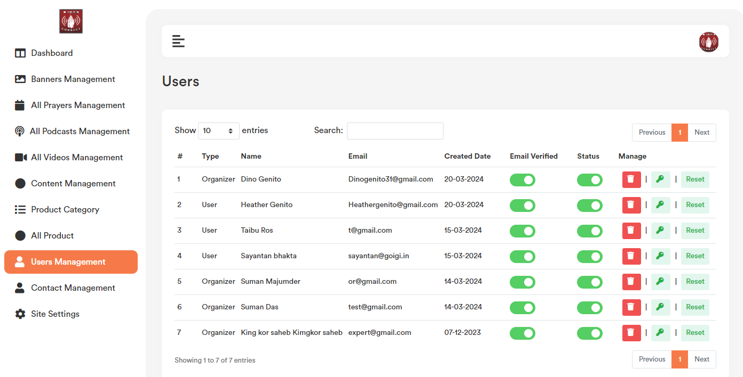

1. **Show Password for Users:**

Users list page for each record click on the “Key” icon, it will show password for particular users Please check the below screenshot.

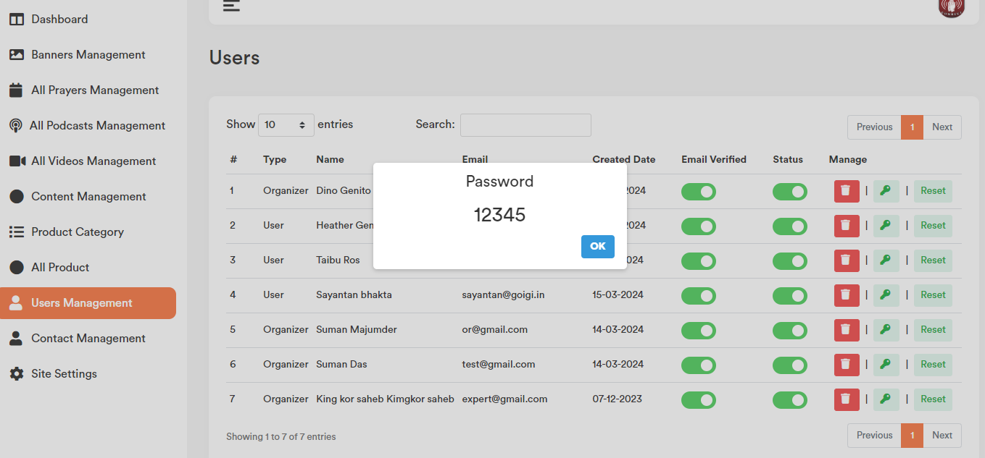

1. **Reset Password for Users:** Users list page for each record if user click on the “Reset” button option, it will open a popup containing the reset password option. After making the change click on the “Update” button. It will update the existing record will the updated data. Please check the below screenshot.

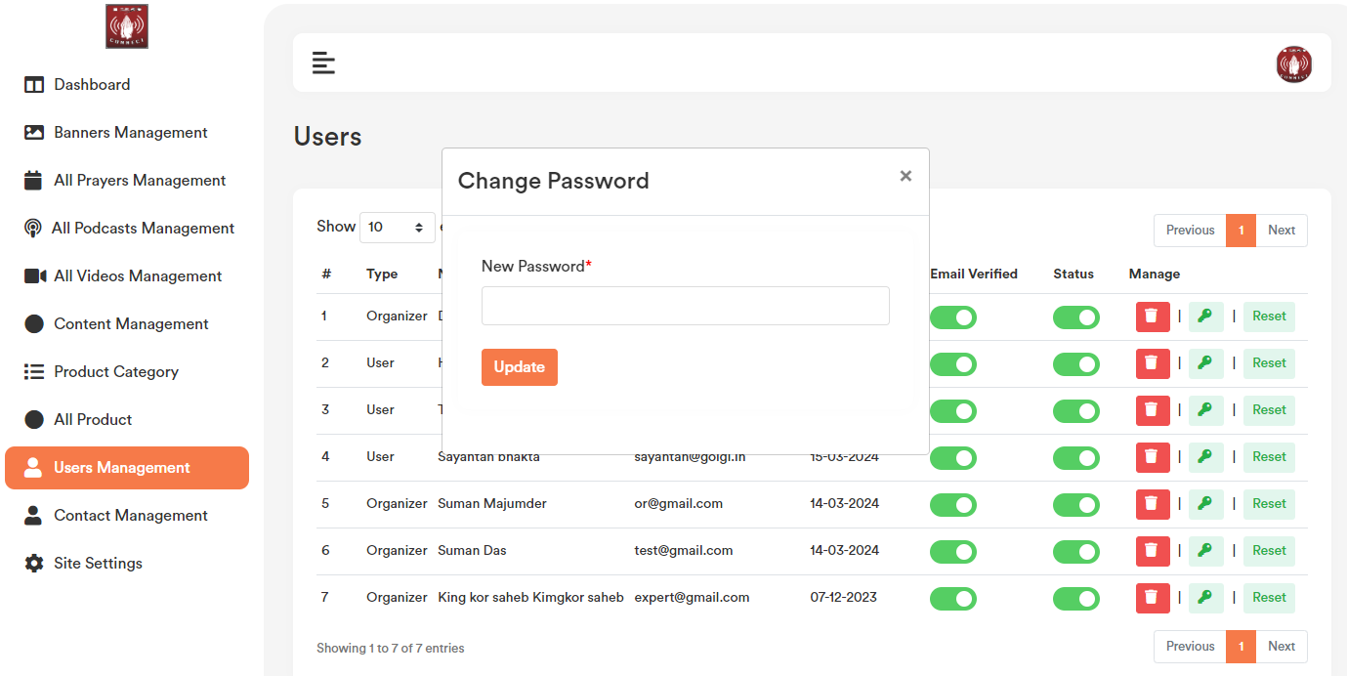

1. **Email Verification:**

For those users, who is unable to verify himself/herself by clicking on the email verification link, admin can verify them by toggle on the “Email Verified” column.

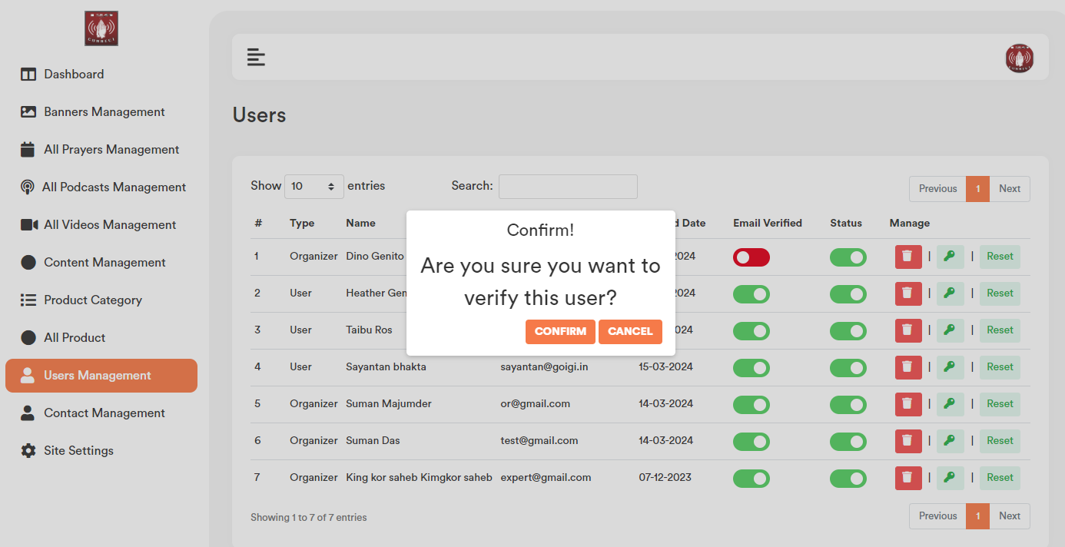

1. **Status (Active/Inactive):**

Admin Can active and inactive userby toggle on the “Status” column.

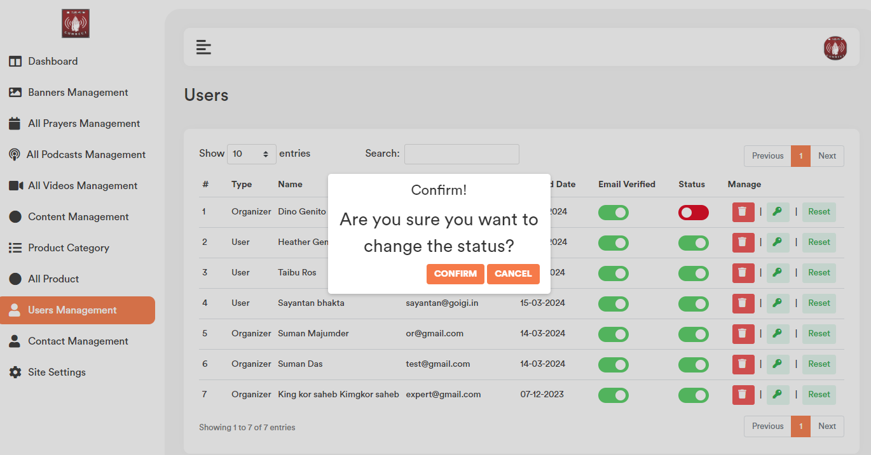

1. **Delete Record:**

If user click on the “Delete” Button, admin will get a confirmation popup. Once confirm it will delete the related data.

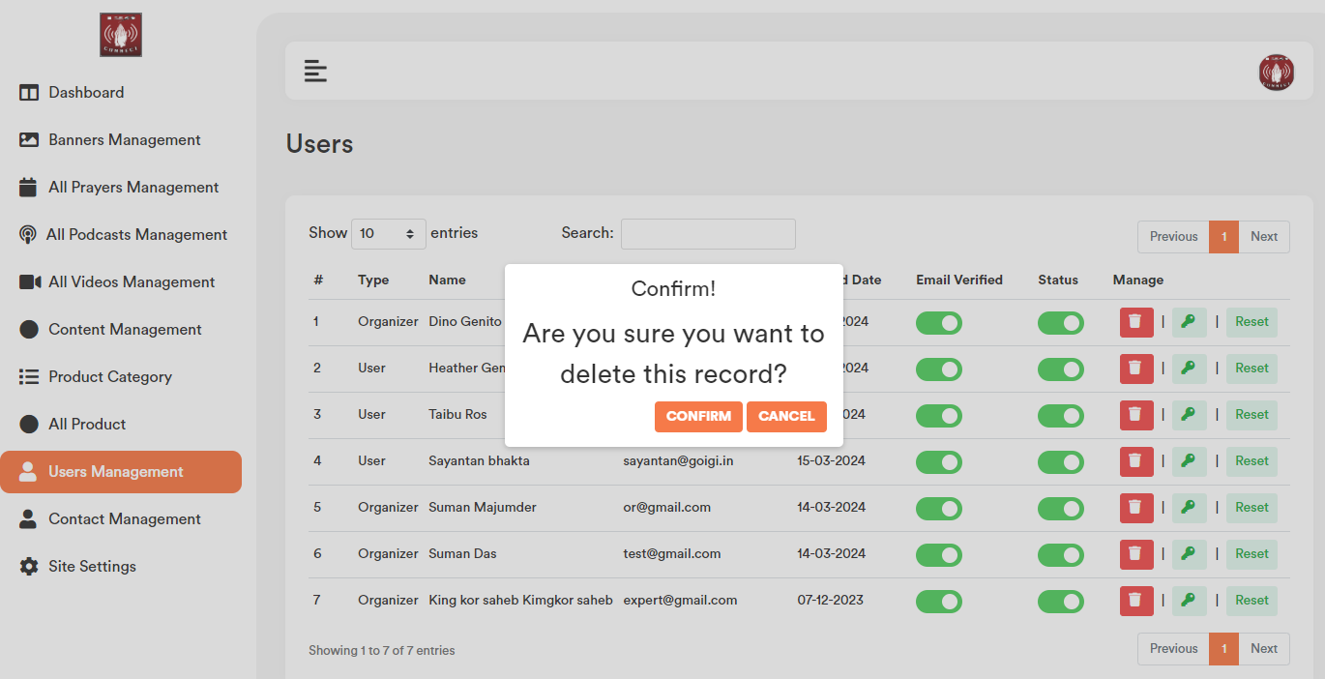

1. **User Search:**

User can search any record by typing text on the search textbox.



1. **Contact Management:**

All the contact person through contact form will be listed in the contact section.

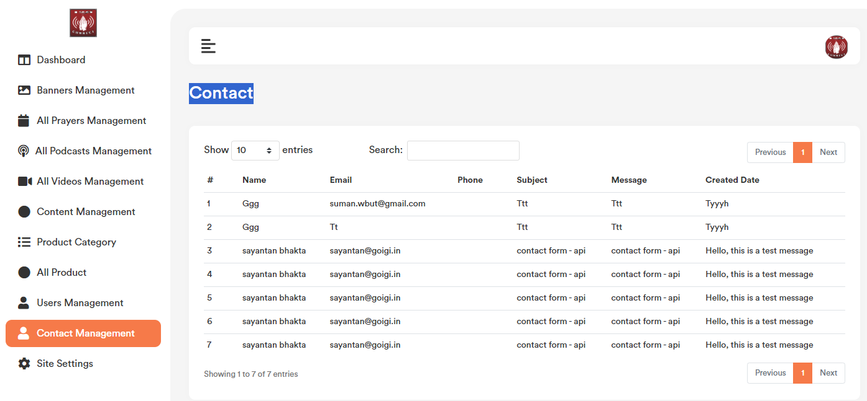

1. **Settings:**

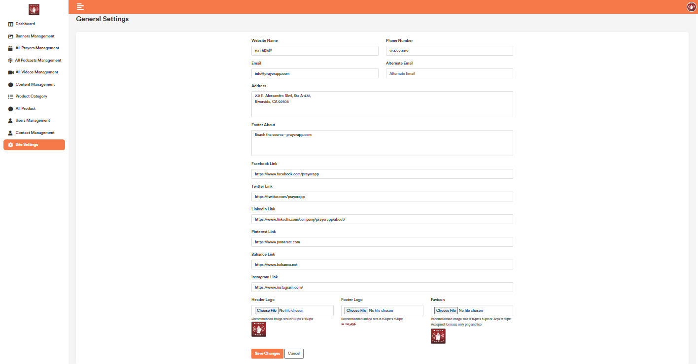

1. **Address:**

Address data will be visible on the website footer and contact us page.

1. **Social Media Link:** This data will bevisible on the website footer.
2. **Header Logo:** Header logo will bevisible on the website header top menu section.
3. **Footer Logo:** Footer logo will be visible on the website footer section.
4. **Favicon:** Favicon will be visible on the top of the browser ison.